Make Your Mark

Tasmanian Local
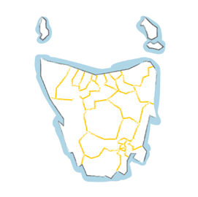
Government Elections 2022

About this paper

This paper is written in an easy to read way.
We use pictures to explain some ideas.

Some words are written in blue.
We explain what these words mean.

This paper is about voting in Local Council Elections in October 2022.

Your right to vote
People with disability can vote in any federal,
state or local government election.

You must vote in local government elections
There have been changes to the Local Government Act 1993
the Local Government Act is a law

The changes mean voting is now compulsory
compulsory is when you have to do something.
You must vote if
- You are 18 years or older
- You are an Australian citizen

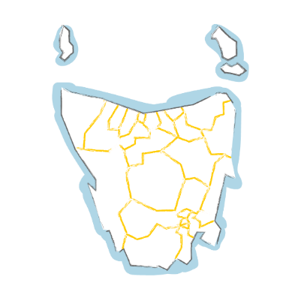
If you usually vote in elections your name is already on a list called the Electoral Roll.

So, your name will now go on the Local Government list for the area where you live.

The electoral roll is now closed
If you are not on the electoral roll already, you do not vote in this election.

To check if you are on the electoral roll, go online
https://check.aec.gov.au/

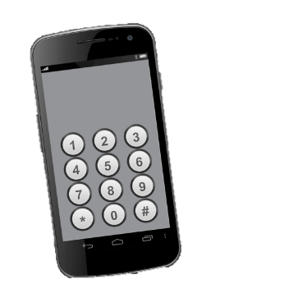

or

ring 132326

Who represents you?
Tasmania has 29 councils across the state.
Each council holds elections for
- Councillors
- Mayor and
- Deputy Mayor

A council has between 7 and 12 councillors.
This includes the Mayor and Deputy Mayor.

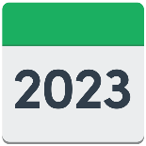
They are all elected for four years.

Use this link to see who represents you in the local government area where you live https://www.tec.tas.gov.au/Services/MyReps/Index.php

Voting is by postal vote

The election is by postal vote only

postal vote means you get the ballot papers in the mail

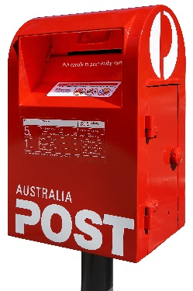
ballot papers are the forms you fill out to vote.

You fill out the ballot papers and post them back.

When do you vote?
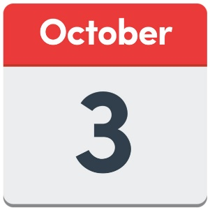

Voting opens on Monday 3 October.

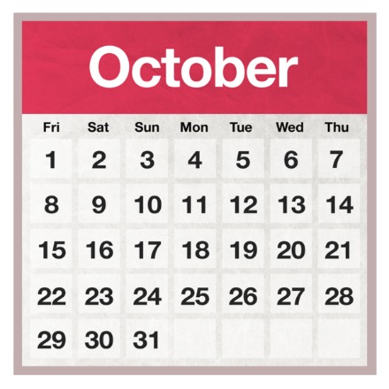
You get a ballot pack in the mail.
It comes between the 3 and 7 October

The ballot pack is an envelope with everything you need to vote.

What to do when the postal ballot pack arrives

- Open the envelope
Inside the envelope is

- 3 ballot papers

- a ballot paper envelope

- a reply paid envelope
reply paid means you do not need a stamp

- a booklet with information from each candidate
candidate is a person standing for Council.

You can ask someone to help you read this.
A friend, family member or support person may be able to help you.

How to return your vote

- Fill out the ballot papers

- Put them in the ballot paper envelope

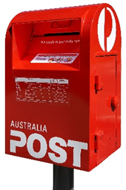
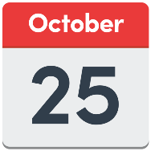
- Put the ballot paper envelope in the reply paid envelope

- Post it before 2pm on Tuesday 25 October.

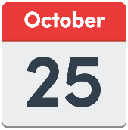

This is when voting closes.

Where to go if you need help

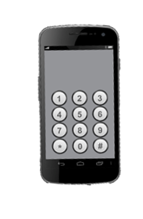
If you need help to fill out the ballot papers, contact
the Tasmanian Electoral Commission

03 6208 8700 or

1800 801 701 or

email ballot.box@tec.tas.gov.au

You can also get help from

  - Your local Neighbourhood Centre
  - Library
  - 26TEN

For more information on elections

Tasmanian Electoral Commission (TEC)
www.tec.tas.gov.au/

Australian Electoral Commission (AEC)
www.aec.gov.au

People who helped with this paper

- Clarence City Council

- Glenorchy City Council

- Hobart City Council

- Kingborough Council

- Huon Valley Council

- 26TEN

- Speak Out Advocacy

This document was produced by Speak Out Tasmania.

We use photosymbols, stock and custom images. You cannot reproduce these images without permission.
For more information about easy read, please contact burnie@speakoutadvocacy.org

